LAB5Q1

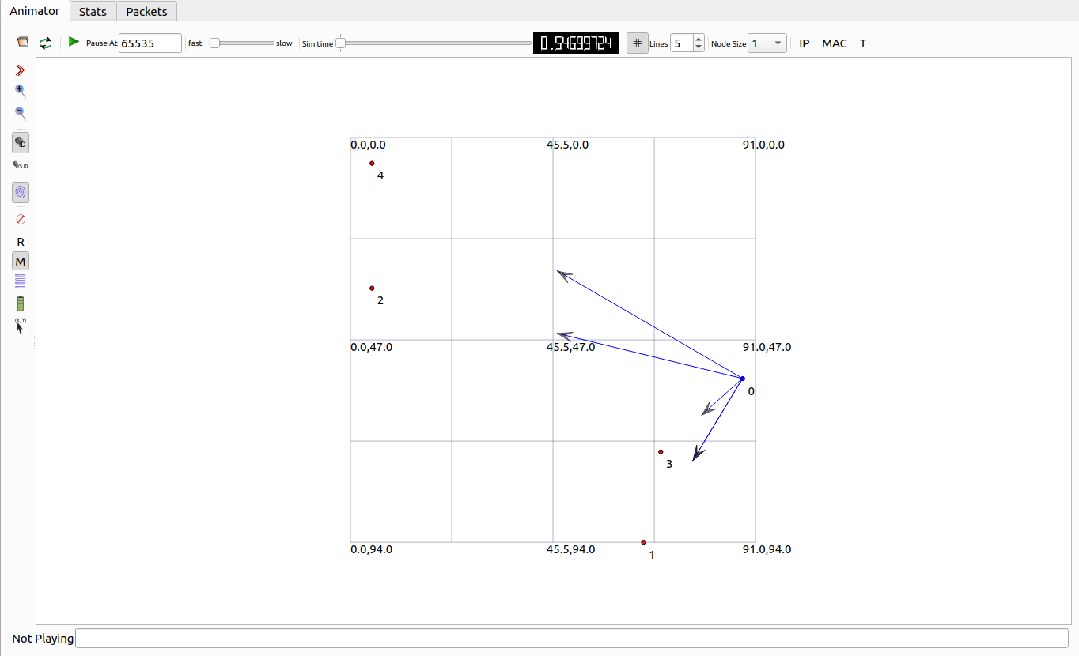

LAB5Q2

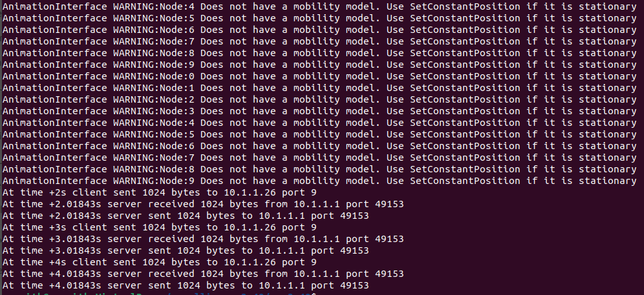

L6Q1

L6Q2

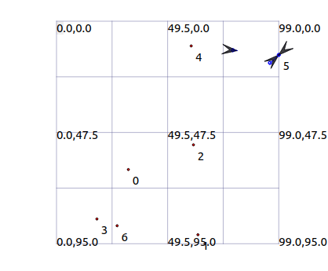



LAB7



